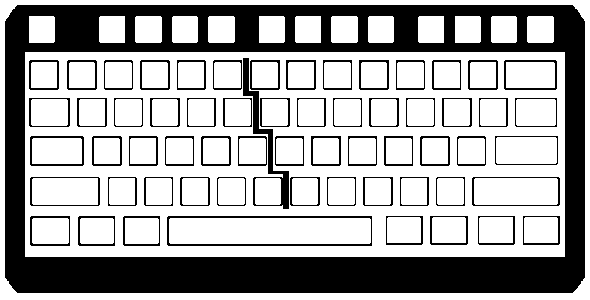
Name_______________________________ Date_______________ Grade _______________ TEST 1
Fill in the MISSING Home Row Letters /9 pts

4
5
6
7
8
9
0
-
=
BS

R
T
Y
U
I
O
P
[
]
\
F
G
H
J
K
L
;
‘
ENTER
B
N
M
,
.
/

[Type a quote from the document or the summary of an interesting point. You can position the text box anywhere in the document. Use the Text Box Tools tab to change the formatting of the pull quote text box.]
Using only the letters you just filled in on the KEYBOARD; create at least 5 real words which you can make to practice these keys.

1.

2.

3.

4.

5.

[Type a quote from the document or the summary of an interesting point. You can position the text box anywhere in the document. Use the Text Box Tools tab to change the formatting of the pull quote text box.]
Write a description of how to open a word processing document that has already been saved to your slice of the cyber world AFTER you have already logged onto the computer….. /5 pts (there are at least 5 steps)
___________________________________________________________________________________________________________________________________________________________________________________________________________________________________________________________________________________________________________________________________________________________________________________________________________________________________________________________________________________________________________________________________________________________________________________________________________________
[Type a quote from the document or the summary of an interesting point. You can position the text box anywhere in the document. Use the Text Box Tools tab to change the formatting of the pull quote text box.]
Write the LETTER you would hit with the key stroke described……. / 2 pts

_________ Right Hand Middle Finger _________ Left Hand Pinky Finger

Write the FINGER and HAND that would be needed to hit the LETTER described……. / 4

_S_ ________________ Hand ______________Finger _J_ _______________ Hand _________Finger

________
1
2
3
4
5
6
7
8
9
0
-
=
BS
Q
W
E
R
T
Y
U
I
O
P
[
]
\
;
‘
ENTER
Z
X
C
V
B
N
M
,
.
/
TAB
CAPS
SHIFT
SHIFT
`
Space Bar
CTRL
CTRL
ALT
ALT

